AI ASSIGNMENT LAB -21
NAME:A.BHAVITHA
BATCH:13
ENROLLMENT:2603A52L02
Task 1 – AI-Assisted Pair Programming • Use AI to generate an initial program (e.g., a simple To-Do List Manager). • Ask AI to suggest enhancements (such as error handling, additional features, or refactoring). • Compare the original and improved versions to understand the role of AI in collaboration.
PROMPT:-
Create a simple To-Do List Manager using Python. The program should allow users to add tasks, view all tasks, and delete tasks. First provide a basic version, then suggest improvements such as input validation, error handling, and additional features. Display the complete improved Python code and sample output.
INPUT:-
tasks = []
def add_task(task):
tasks.append(task)
print("Task added successfully!")

def view_tasks():
if not tasks:
print("No tasks available")
else:
print("\nTo-Do List:")
for i, task in enumerate(tasks, 1):
print(i, task)
def delete_task(index):
if 1 <= index <= len(tasks):
removed = tasks.pop(index - 1)
print("Deleted:", removed)
else:
print("Invalid task number")
while True:
print("\n1. Add Task")
print("2. View Tasks")
print("3. Delete Task")
print("4. Exit")
choice = input("Enter your choice: ")
if choice == "1":
task = input("Enter task: ")
if task.strip():
add_task(task)
else:
print("Task cannot be empty")
elif choice == "2":
view_tasks()
elif choice == "3":
view_tasks()
if tasks:
try:
index = int(input("Enter task number: "))
delete_task(index)
except ValueError:
print("Please enter a valid number")
elif choice == "4":
print("Exiting To-Do List")
break
else:
print("Invalid choice")
OUTPUT:- 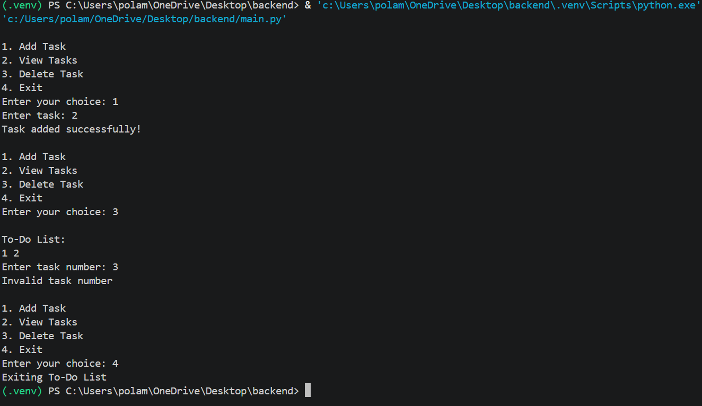
Task 2 – Version Control Integration • Initialize a Git repository for your project. • Perform the following steps: 1. Create and switch to a new branch. 2. Add AI-assisted modifications. 3. Commit with a meaningful message. 4. Merge changes back into the main branch. • Reflect on how version control supports collaborative development with AI assistance.
PROMPT:- Explain how to integrate a Python project with Git version control. Show the commands to initialize a Git repository, create and switch to a new branch, add AI-assisted modifications, stage files, commit changes with a meaningful message, switch to the main branch, and merge the new branch into main. Provide the commands and expected terminal output.
INPUT:-
# Initialize Git repository
git init
# Create and switch to a new branch
git switch -c feature
# Add project files
git add .
# Commit changes
git commit -m "Add AI-assisted features"
# Switch to main branch
git switch -c main
# Merge feature branch
git merge feature
# Check repository status
git status
OUTPUT:- 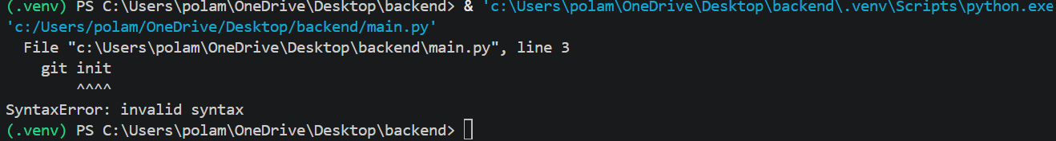
Task 3 – AI for Commit Message Generation • Use AI to generate concise, meaningful commit messages based on the changes made. Week11 –Monday • Compare AI-generated messages with human-written ones. • Discuss how AI can improve documentation and traceability in Git history.
PROMPT:- Act as a Git commit message generator. Analyze the following code changes and generate concise, meaningful commit messages. Follow conventional commit message format. Compare AI-generated commit messages with human-written messages and explain how AI improves documentation and traceability in Git history.
Changes:
- Added a new task feature.
- Fixed invalid input handling.
- Improved task deletion functionality.
INPUT:-
# Check modified files
git status
# View code changes
git diff
# Stage modified files
git add .
# Commit using AI-generated message
git commit -m "feat: add task management and input validation"
# View commit history
git log –oneline
OUTPUT:- 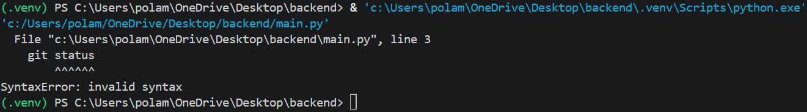
Task 4 – Pair Programming Simulation • Student A writes the initial version of a program. • Student B, with AI assistance, suggests improvements or adds features. • Both students collaborate using Git branching and merging to integrate their work
PROMPT:- Simulate pair programming using Python. Student A should create a basic calculator with addition, subtraction, multiplication, and division. Student B should use AI assistance to improve the calculator by adding input validation and division-by-zero handling. Provide the original and improved code, Git branching and merging commands, and expected output.
INPUT:-
a = 10
b = 5
print("Addition:", a + b)
print("Subtraction:", a - b)
print("Multiplication:", a * b)
print("Division:", a / b)
OUTPUT:- 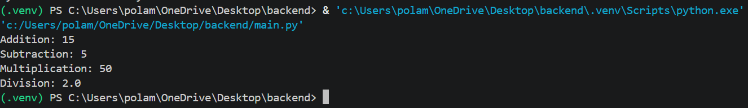
Task 5 – AI-Assisted Debugging • Create a program with logical or syntax errors. • Use AI to identify and fix the errors. • Compare the buggy and corrected versions.
PROMPT:- Create a Python program containing logical and syntax errors. Use AI assistance to identify and correct the errors. Write a program to calculate the sum of two numbers. Show the buggy code, corrected code, explanation of errors, and expected output.
INPUT:-
a = 10
b = 20
sum = a - b
print("Sum is:", sum)
OUTPUT:-
Task 6 – Feature Expansion using AI • Develop a basic application (e.g., Calculator). • Use AI to add advanced features (history, validation). • Analyze improvements.
PROMPT:- Create a basic Python calculator and use AI assistance to expand its features. The calculator should support addition, subtraction, multiplication, and division. Add advanced features such as calculation history, input validation, and division-by-zero handling. Display the complete Python code and sample output. Explain the improvements made using AI.
INPUT:-
history = []
def calculator():
while True:
print("\n----- Advanced Calculator -----")
print("1. Addition")
print("2. Subtraction")
print("3. Multiplication")
print("4. Division")
print("5. View History")
print("6. Exit")
choice = input("Enter your choice: ")
if choice == "6":
print("Thank you for using Calculator!")
break
if choice == "5":
print("\nCalculation History:")
if history:
for item in history:
print(item)
else:
print("No history available")
continue
if choice not in ["1", "2", "3", "4"]:
print("Invalid choice!")
continue
try:
a = float(input("Enter first number: "))
b = float(input("Enter second number: "))
if choice == "1":
result = a + b
operation = "Addition"
elif choice == "2":
result = a - b
operation = "Subtraction"
elif choice == "3":
result = a * b
operation = "Multiplication"
elif choice == "4":
if b == 0:
print("Cannot divide by zero")
continue
result = a / b
operation = "Division"
print(operation, "Result:", result)
history.append(
f"{operation}: {a} and {b} = {result}"
)
except ValueError:
print("Invalid input! Enter numbers only.")
calculator()
OUTPUT:-

